Profile of Alwar, Rajasthan – Past, Present, and Vision for Inclusive Development

1. Historical and Cultural Background of Alwar
Alwar, one of the oldest cities in the state of Rajasthan, holds a distinguished place in India’s historical and cultural heritage. Situated in the Aravalli mountain range, Alwar was historically known as the gateway to Rajasthan. The city was ruled by Rajput dynasties, Mughal administrators, and later the princely state of Alwar under British paramountcy. Its rich legacy is reflected in landmarks such as the Bala Quila Fort, City Palace, Moosi Maharani Ki Chhatri, Sariska Tiger Reserve, and numerous temples, mosques, and stepwells that symbolize centuries of coexistence among diverse communities.
Historically, Alwar was a center of trade, crafts, and education. Hindu and Muslim communities jointly contributed to its economic, social, and cultural development, making it a microcosm of India’s pluralistic civilization.

2. Recent Communal and Socio-Economic Challenges
In recent decades, Alwar has faced challenges typical of rapidly urbanizing and demographically diverse cities. These include:
- Communal tensions and sporadic conflicts arising from socio-economic disparities, misinformation, and political polarization.
- Urban infrastructure stress, including water scarcity, sanitation gaps, housing shortages, and traffic congestion.
- Youth unemployment and lack of inclusive skill development opportunities, which can increase social vulnerability.
- Environmental degradation, particularly deforestation in the Aravalli range and pressure on Sariska’s ecosystem.
These challenges require holistic, non-partisan, and technology-driven interventions focused on peacebuilding, governance, and sustainable urban development.

3. Role of Human Settlement Technology Centre (NGO)
The Human Settlement Technology Centre (HSTC) aims to work at the intersection of law, technology, community development, and sustainable urban planning. In Alwar, HSTC proposes to:
- Promote communal harmony and dialogue through interfaith mediation, youth peace programs, and community workshops.
- Implement smart and sustainable infrastructure models, including water management, sanitation technologies, and low-cost housing innovations.
- Support digital governance and legal literacy, empowering citizens to access rights, public services, and grievance redressal mechanisms.
- Collaborate with local authorities, universities, and civil society organizations to create data-driven urban solutions.

4. Contribution of Adv. Gitesh Khannaa and K.K. Khanna & Associates
As International Lawyers, Solicitors, Mediators, and Arbitrators, Adv. Gitesh Khannaa and K.K. Khanna & Associates commit to contributing to Alwar’s development through:
- Community Mediation & Peacebuilding: Establishing mediation centers for resolving communal, business, and civil disputes peacefully.
- Legal Aid & Governance Support: Providing pro-bono legal assistance to marginalized communities, startups, and civic initiatives.
- Policy Advisory: Assisting local institutions in drafting inclusive urban policies, investment frameworks, and dispute-resolution mechanisms.
- International Partnerships: Leveraging global networks (UN, EU, development agencies, and NGOs) to attract technical assistance and funding for Alwar.
- Capacity Building: Training local lawyers, students, and community leaders in ADR (Alternative Dispute Resolution), negotiation, and international legal standards.

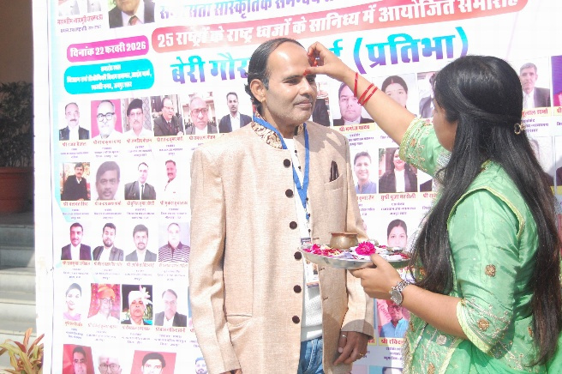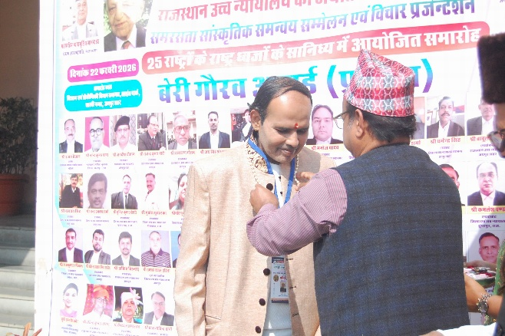
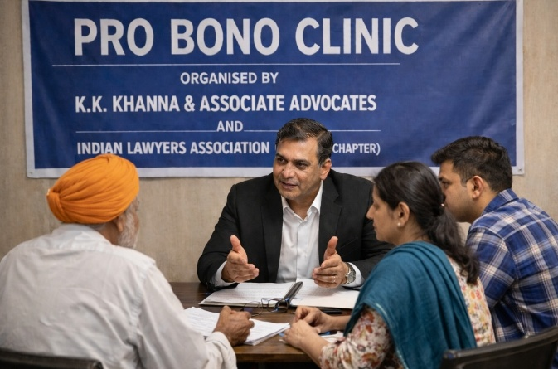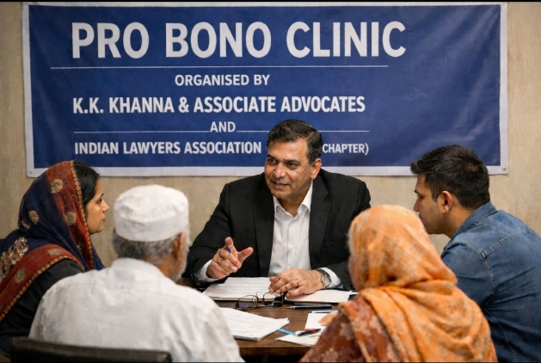

5. Vision for Transformative Change in Alwar
The combined efforts of HSTC and K.K. Khanna & Associates envision Alwar as:
- A model city for communal harmony and intercultural dialogue.
- A smart, resilient, and sustainable urban settlement.
- A hub for legal innovation, mediation, and international dispute resolution training.
- A safe and inclusive city attracting ethical investments, startups, and social enterprises.

Seed Phrase Theme: ATTRACTING DONATIONS

Inspiring Appeal for Donors and Philanthropic Institutions
Alwar stands at a historic crossroads—where its glorious past meets the urgent demands of the present and the limitless possibilities of the future. With strategic support, Alwar can transform into a beacon of communal harmony, sustainable infrastructure, and legal empowerment for India and the world.
Your donation is not merely a contribution; it is an investment in peace, justice, and sustainable human settlements.
Through your support, we will:
- Build technology-enabled community mediation centers.
- Develop sustainable housing and urban infrastructure prototypes.
- Empower youth and women through legal education and skill development.
- Protect Alwar’s ecological heritage and cultural diversity.
- Create a replicable model for conflict-resilient and inclusive cities globally.

Call to Action
We invite global philanthropies, CSR foundations, international development agencies, corporate donors, and individual benefactors to partner with us in reshaping Alwar’s future.
Together, we can convert conflict into collaboration, vulnerability into resilience, and heritage into a sustainable future.
Attracting Donations – Building Peaceful Cities – Empowering Communities – Advancing International Legal Standards.

