**ILORIN SOUTH, NIGERIA: CITY OF PEACE**

**Historical Background and Cultural Heritage of Tanke Community (Ilorin South, Nigeria)**

Tanke Community, located in Ilorin South Local Government Area of Kwara State, Nigeria, is a historically rich and culturally harmonious settlement that dates back to the 18th century. According to Alhaji Umar Salaudeen, the fifth and current Alangua (the community head) of Tanke, the community was founded through the peaceful cohabitation of two major ethnic groups: the Yoruba and the Fulani. Originally, the Yoruba people migrants from Ikoyi-ile in Oyo State were hunters, while the Fulani descendants of Balogun Fulani of Ilorin were pastoralists. The two groups settled in the area, agreed to live together peacefully, and collectively established what is known today as Tanke Community. Geographically, Tanke shares boundaries with Maraba to the west, GRA to the south, and Kulende to the east. Its large landmass provided ample space for farming, hunting, and pastoral activities.

The settlement pattern reflected their respective livelihoods: the Yoruba occupied the upper part of the land, while the Fulani settled in the lower areas. Despite their different lifestyles, the two groups collaborated in building homes known as Àeré (a type of hut), contributing to the cultural and architectural development of the area. The name “Tanke” is said to have originated from a culturally significant exchange. When the Fulani observed the industriousness of the Yoruba youths working the land, they remarked in admiration, “Awon omo yi o kere” meaning “These children are not lazy.” In response, a Yoruba elder said “Tankere”, affirming the statement. Over time, the word evolved to become the community's name: Tanke.

Today, both the Yoruba and Fulani populations are indigenous to Tanke, united by a shared Islamic faith. Governance and religious responsibilities are cooperatively managed: the Yoruba, being more settled, provide community leadership through the office of the Alangua (the community head), while the Fulani, who often migrate with their livestock, serve as Imams (Islamic Religion Leader). This long-standing agreement reflects a unique model of peaceful coexistence, mutual respect, and shared governance. In the early days of Tanke community, before the construction of government roads, men would engage in communal bush clearing to create footpaths connecting Tanke to neighbouring areas such as Maraba and Sabo Oke. During these voluntary efforts, women supported the work by preparing traditional meals such as (eko ati akara) pap and bean cakes, offering relief and nourishment after long hours of labour.

The two major ethnic groups Yoruba and Fulani have long practised their cultural traditions with mutual understanding and respect. This harmonious coexistence has fostered a spirit of tolerance, unity, and enduring peace within the community. Among the Fulani, marriage ceremonies are rich with cultural expressions. During such events, various forms of entertainment including wrestling and traditional dances are performed over the course of one to two weeks. One notable practice is the early morning extraction of cow milk to produce local cheese, which remains a cherished Fulani custom. The Yoruba, on the other hand, observe a unique marriage tradition where the groom ceases all work for about a month before the wedding day. During this time, the bride’s family assumes full responsibility for his welfare. The Yoruba wedding celebration typically lasts for a full week, filled with rituals, music, and feasting.

The traditional leadership of Tanke community has evolved over time, with five individuals having served as Alangua (the community head) from its early formation to the present day. The list of past and current Alanguas (the community head) is as follows:

* First Alangua (the community head):- ***Baba Agba*** (He was respectfully called Baba Agba, meaning “Elderly Father,” in recognition of his age and wisdom.)
* Second Alangua (the community head): ***Muhammadu***
* Third Alangua (the community head): ***Salaudeen***
* Fourth Alangua (the community head): ***Karimu***
* Fifth and Current Alangua (the community head): ***Alhaji Umar Salaudeen***

Under the leadership of Alhaji Umar Salaudeen, the fifth and current Alangua (the community head), Tanke community has grown to include twenty-four (24) sub-communities, each headed by a Magaji (local family/community head). These sub-communities include:

* Magaji-Fate
* Oko-Oba Fate
* Iledu
* Bubu
* Ajanaku
* Akata
* Agbo-Iledu
* Oko-Oba
* Masudo
* Gago
* Jalala
* Balogun
* Aleniboro
* Agbede
* Budo-Isale
* Odo-Koto
* Gaa-Ajanaku
* Fajeromi
* Ago Ayekale
* Asufa
* Temidire
* Gaa-Olorundo
* Ori-Oke
* Ojutaye

This administrative structure ensures local participation in decision-making, promotes traditional values, and supports the peaceful coexistence of the diverse ethnic and religious groups within the Tanke community. Over the years, Tanke has evolved with the influx of new residents and modern developments. The arrival of students from the University of Ilorin has significantly increased the community’s population, turning it into both a residential and educational hub. Despite this transformation, Tanke continues to preserve its rich cultural heritage and thrives as a diverse and vibrant community, attracting visitors and fostering peaceful coexistence among all residents.

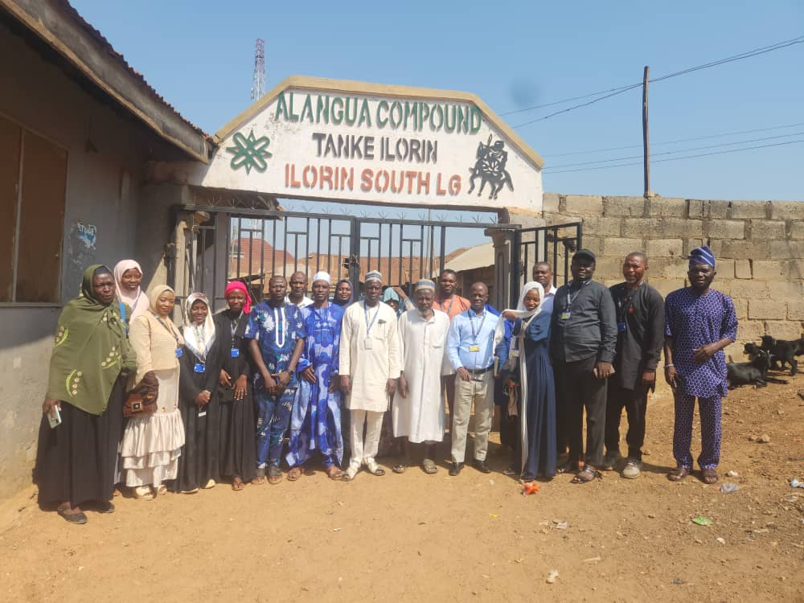

Fieldwork Team with Director, Center for Peace and Security Studies, Al-Hikmah University, Dr. A.A. Adekola along with Alangua (the community head) at his Palace in Tanke, Ilorin South

**Traditional Channels of Peacemaking, Conflict Prevention, Management, and Peacebuilding in Tanke Community**

In the pursuit of lasting peace, many communities continue to rely on traditional mechanisms for conflict prevention, management, and resolution. In Tanke Community, a decentralized traditional system forms the backbone of local peacebuilding, leveraging familial and communal leadership structures to address disputes and foster social harmony. This approach represents a hierarchical yet inclusive structure, with each tier playing a distinct role in the resolution of conflict, from minor household disputes to more complex inter-group tensions. The following are the primary channels involved in traditional peacebuilding in Tanke:

* **Family Head:** The family head serves as the first point of intervention in most domestic conflicts, especially in cases involving marital disagreements and land disputes within the family unit. Their role is crucial in promoting harmony at the grassroots level, reflecting the deep respect accorded to family elders in local governance and conflict resolution.
* **Magaji** ***(local family/community head):*** The Magaji (local family/community head) typically the oldest or most influential member of an extended family or compound, is entrusted with leadership responsibilities beyond the nuclear family. In Yoruba tradition, the Magaji (local family/community head) mediates conflicts that surpass the authority of the family head, such as disputes over land boundaries or security-related concerns, playing a vital role in maintaining order within the sub-community.
* **Alangua** ***(the community head):*** The Alangua (the community head) serves as the overall head of Tanke Community. When disputes cannot be resolved at the family or compound level, they are brought to the Alangua (the community head), who collaborates with a council of elders to deliberate and provide just resolutions. This stage represents a structured and community-based effort to manage conflicts that affect broader sections of the population.
* **Balogun Fulani** ***(Traditional Head of the Fulani Clan):*** Cases that remain unresolved at the Alangua’s level, or those requiring higher authority for appeal, are forwarded to the Balogun Fulani (Traditional Head of the Fulani Clan). This figure plays an important appellate role, especially given the historical Fulani presence and leadership significance in Ilorin Emirate traditions. The Balogun Fulani’s (Traditional Head of the Fulani Clan) involvement reflects the community’s dedication to a thorough, multi-layered conflict resolution process.
* **Emir of Ilorin *(King):*** At the apex of the traditional hierarchy is the Emir of Ilorin, who serves as the highest authority in traditional governance and peacebuilding within the emirate. When all other efforts fail, or when disputes are too complex or sensitive, they are referred to the Emir's palace for final resolution. This demonstrates the community’s recognition of the centralized role of traditional leadership in ensuring justice, reconciliation, and enduring peace.

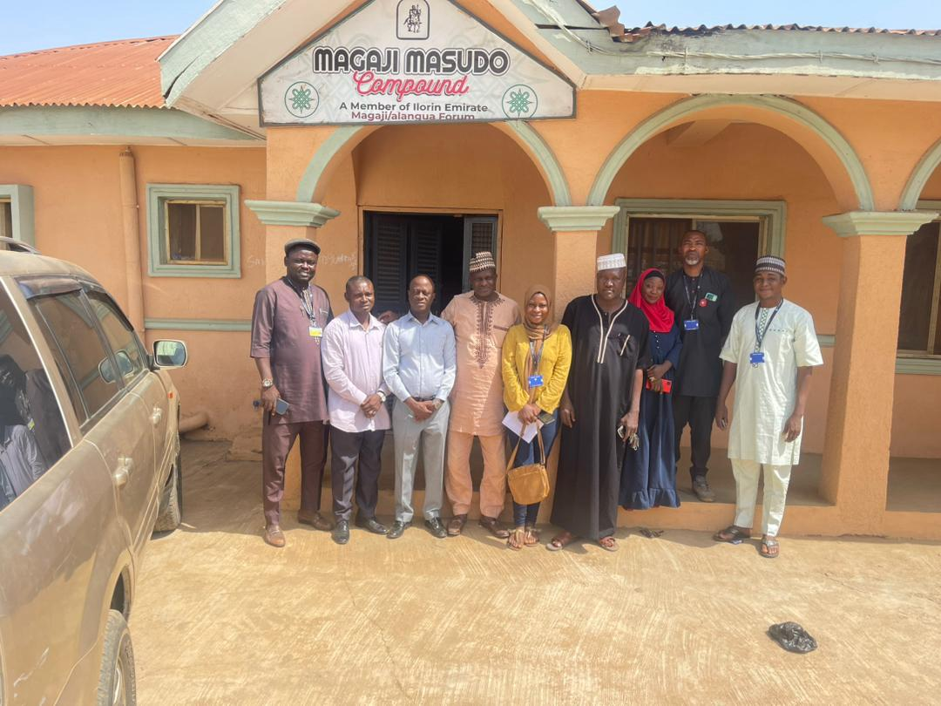Community Fieldwork Team with Magaji Masudo (family head of Masudo) at Masudo Compound in Tanke, Ilorin South

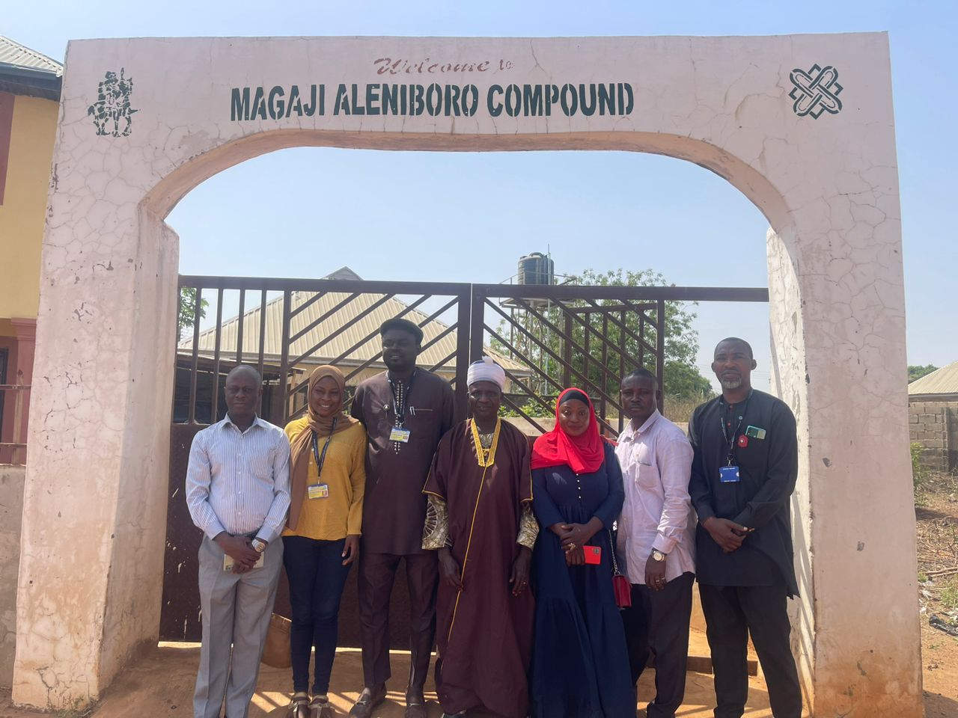Community Fieldwork Team with Magaji (family head of Aleniboro) at Aleniboro Compound in Tanke, Ilorin South

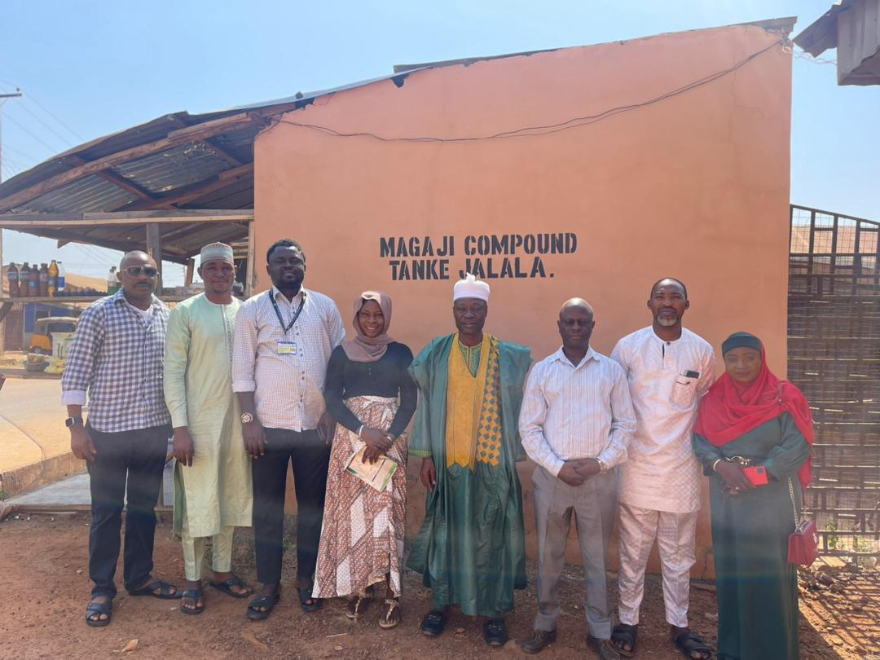

Community Fieldwork Team with Magaji (family head of Jalala) at Jalala Compound in Tanke, Ilorin South

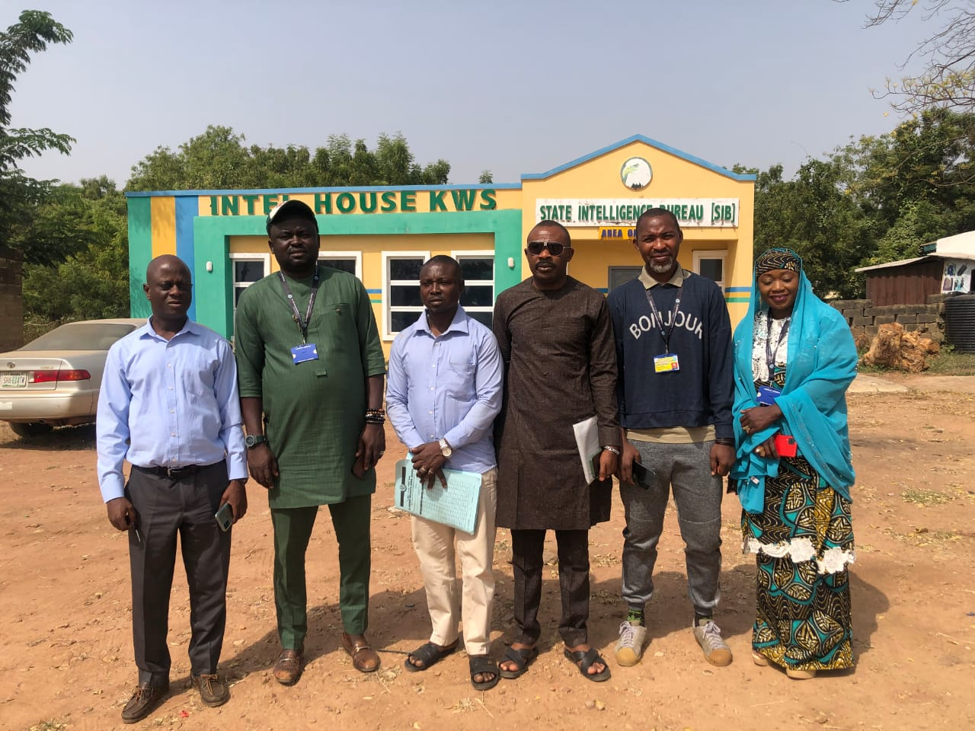

Community Fieldwork Team, visit to “F” Division Police Station, Tanke. Ilorin South

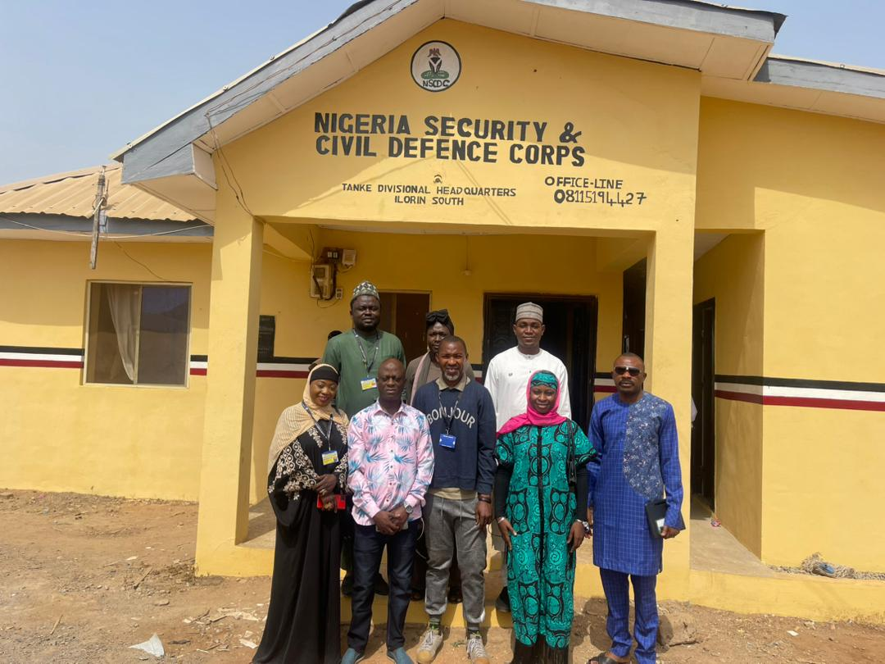

Community Fieldwork Team, visit to Nigeria Security & Civil Defence Corps, Tanke Divisional Headquarters, Ilorin South

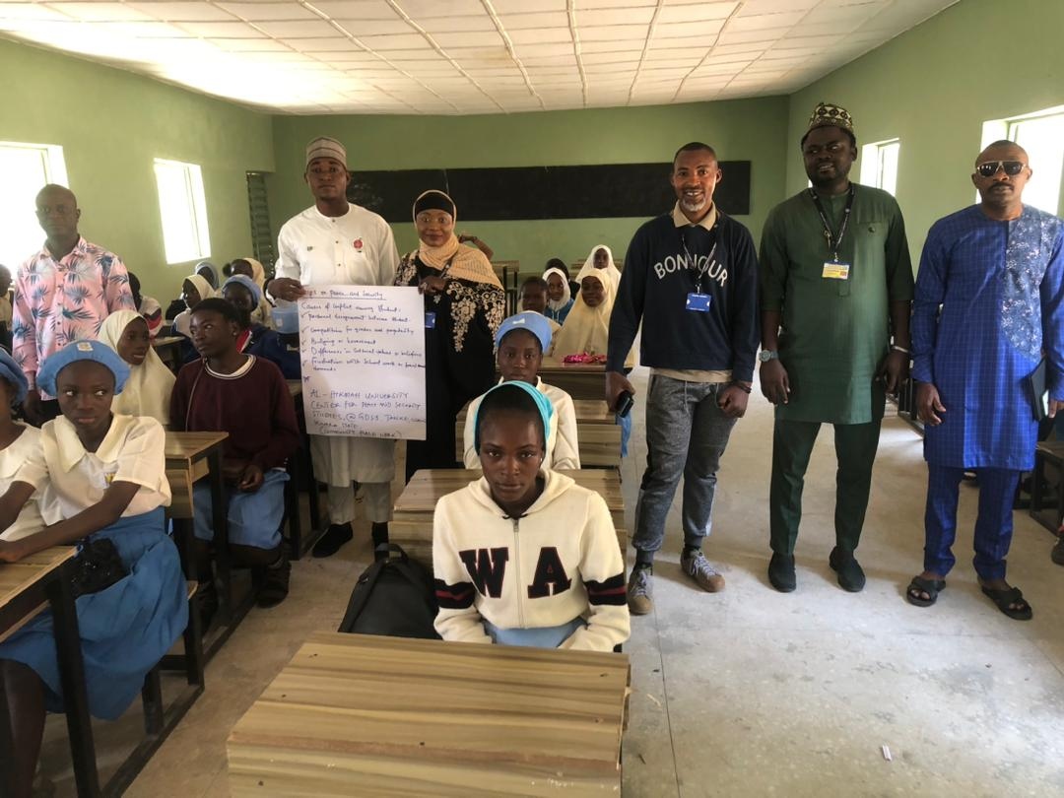

Community Fieldwork Team, visit to Government Day Secondary School Tanke. Ilorin South

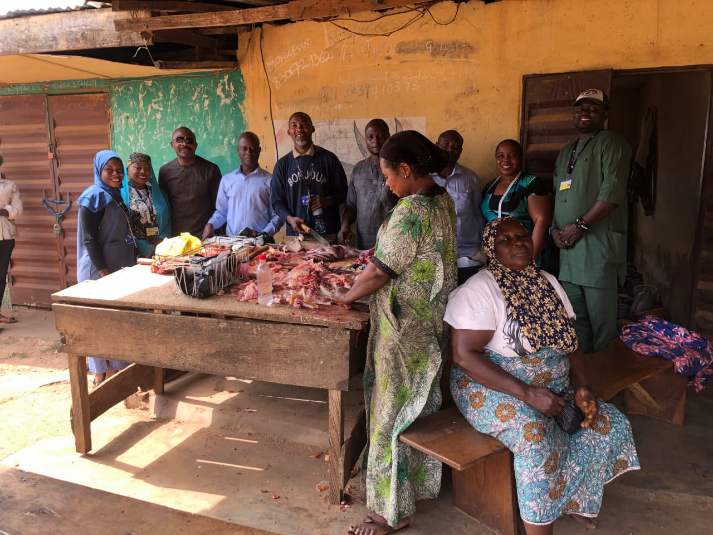

Community Fieldwork Team, visit to Baba-Loja (men head of the market) of Tanke, Ilorin South

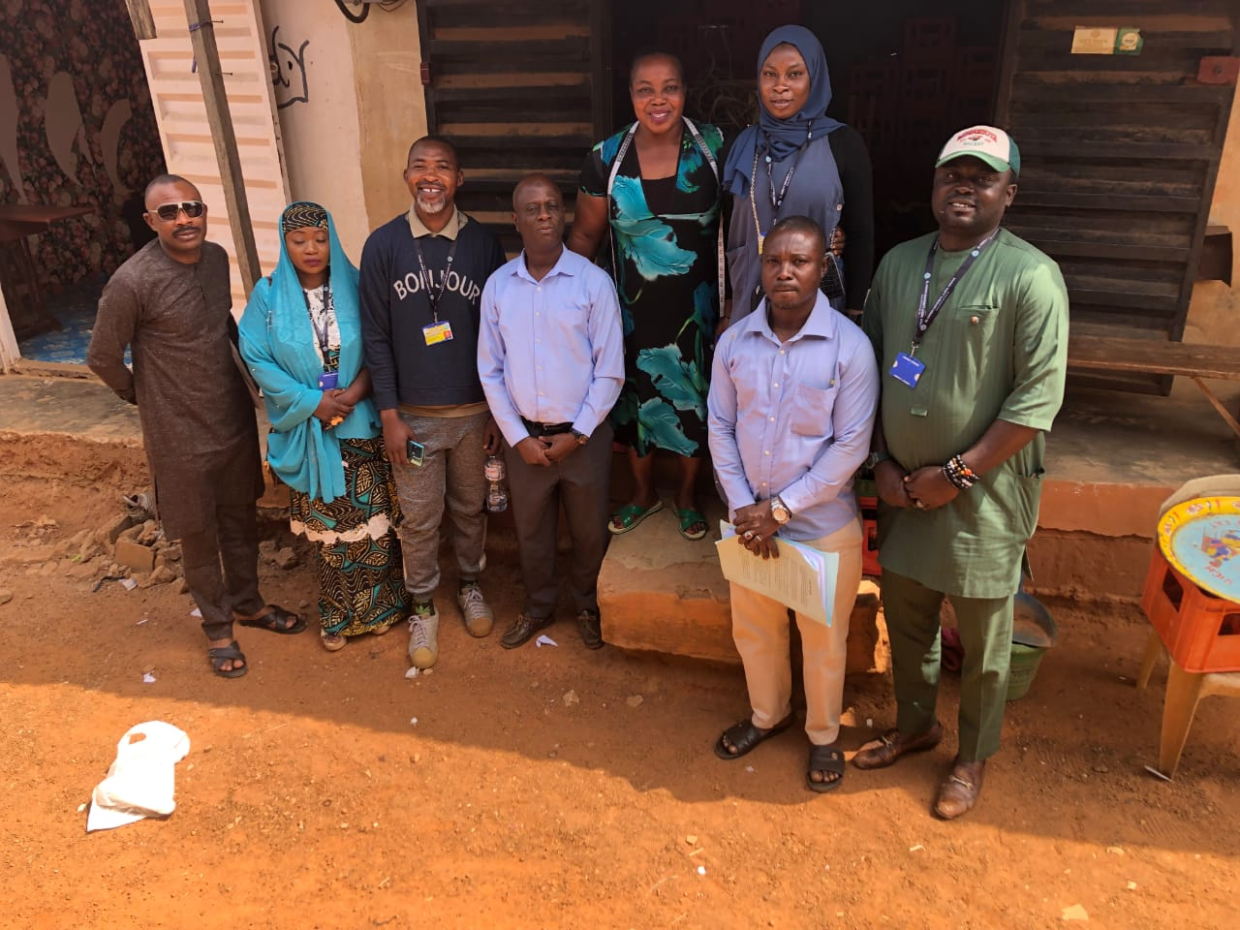

Community Fieldwork Team, visit to Iya-Loja (women head of the market) of Tanke, Ilorin South

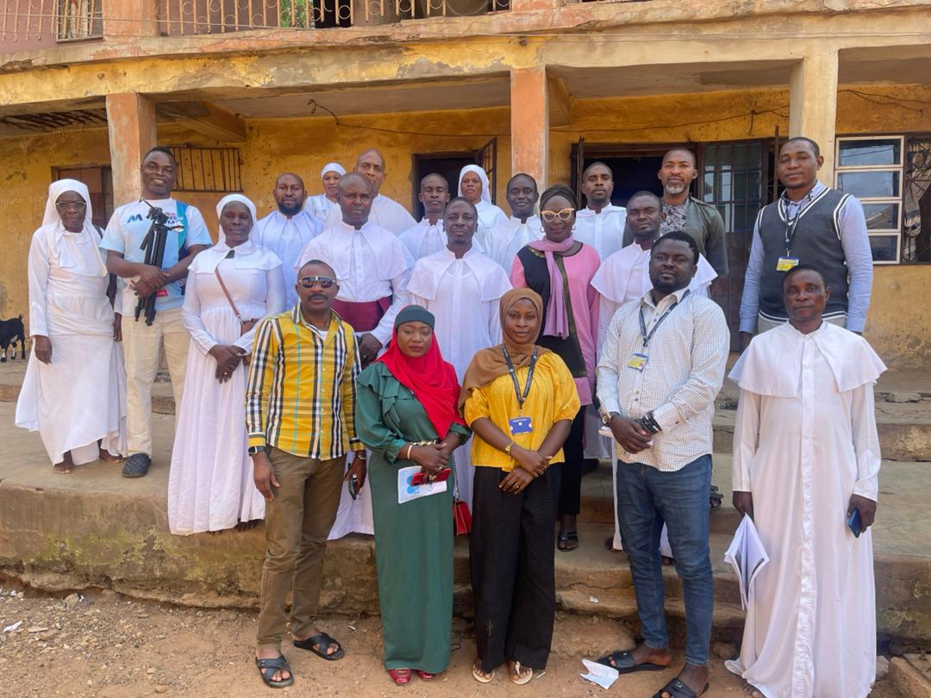

Community Fieldwork Team with Brotherhood on the Cross of Christ Celestial Church at Alangua (the community head) Palace. Tanke, Ilorin South

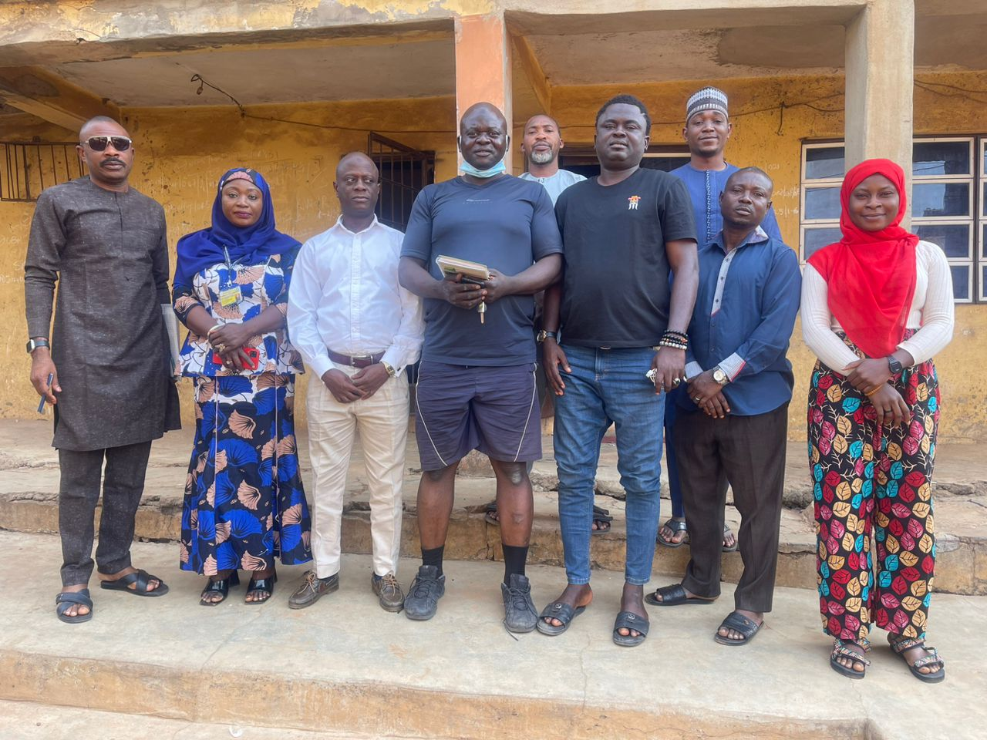

Community Fieldwork Team with P.R.O Tanke Community Youth Association, Mr, Ibrahim at Alangua the community head) Palace. Tanke, Ilorin South

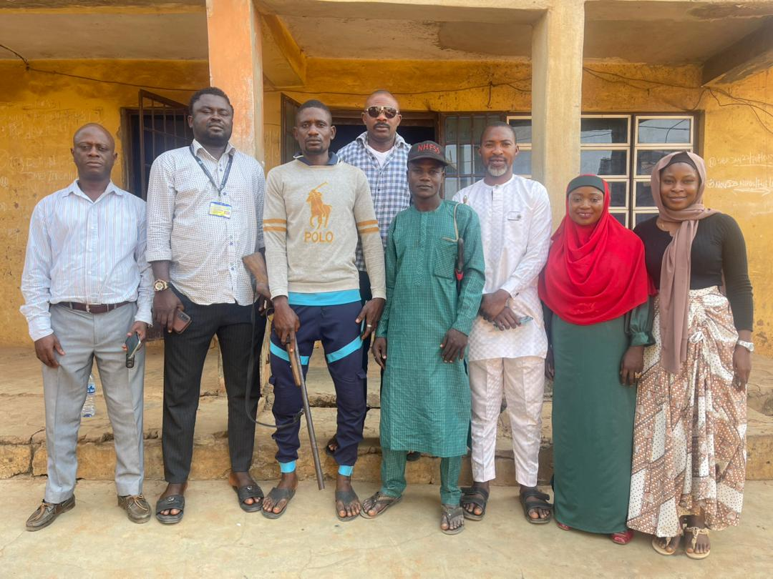

Community Fieldwork Team with Commander NHFSS Ilorin South Division at Alangua (the community head) Palace, Tanke, Ilorin South

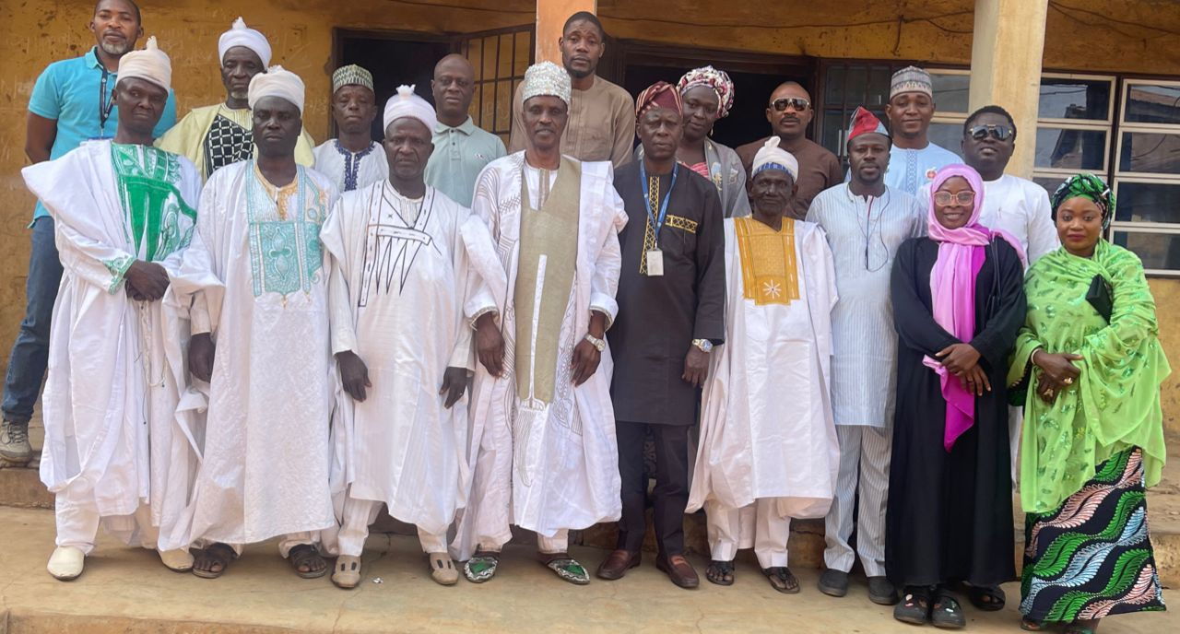

Alangua (the community head) of Tanke, Magajis,(local family head) & Fieldwork Team with Director, Center for Peace and Security Studies, Dr. A.A Adekola, Dr. Idowu and Mr, Olowolagba during the final day of the community Fieldwork