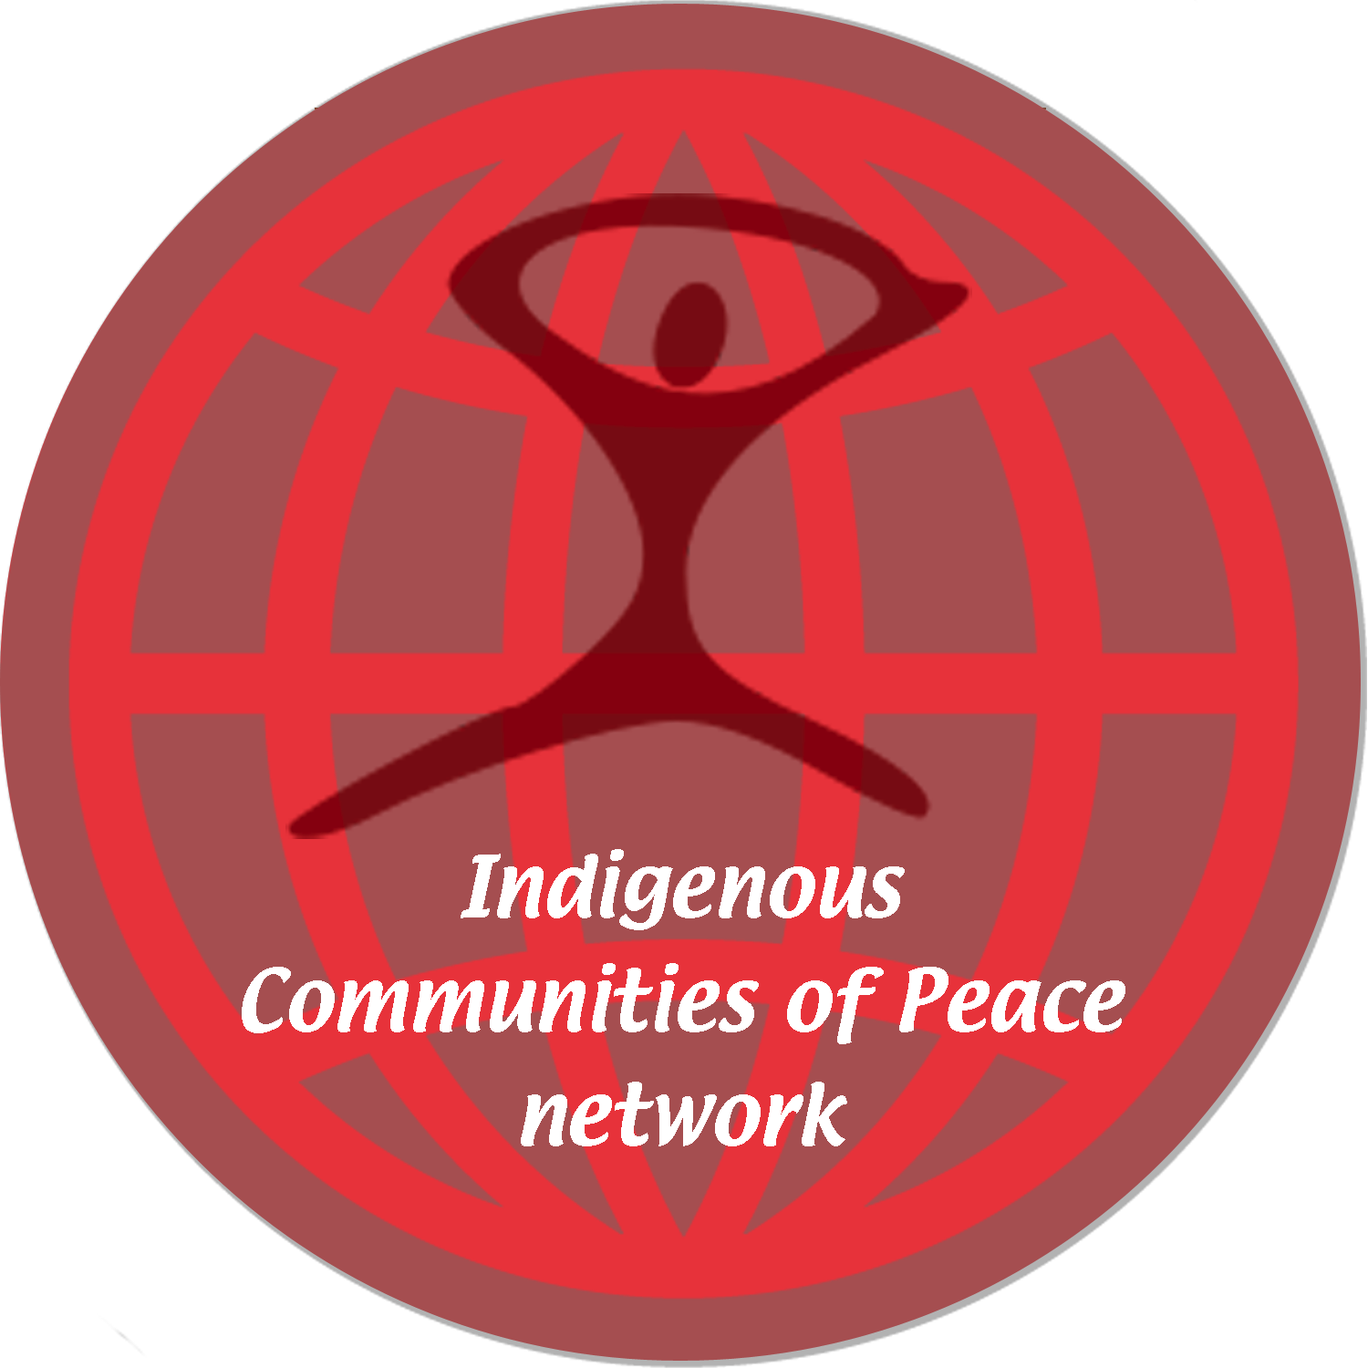

Dear Colleague in Peace,

Thank you for inquiring about the Indigenous Communities of Peace network, a service of International Cities of Peace. We are a nonprofit, tax-exempt organization dedicated to connecting, promoting, and encouraging Indigenous Communities of Peace. Members of an Indigenous Leadership Council around the globe are creating an inclusive, non-polarizing network to honor their traditions and to work for peace in their local communities and beyond.

VISION: To foster peace as a consensus value in Indigenous Communities around the world.

MISSION: To network, encourage, document, and provide resources and information for leaders and organizations working to make peace a consensus value through global Indigenous Communities of Peace initiatives.

First and foremost in this global endeavor toward creating a culture of peace is to reject violence and self-define our communities as people of peace. The Network supports indigenous communities that are by history, resolution, proclamation, or simply citizens working together to self-define as Indigenous Communities of Peace.

Attached is a Letter of Intent for individuals and organizations to establish an Indigenous Community of Peace. We hope you and other citizens of your community will sign the letter and return it by email.

On our website (www.internationalcitiesofpeace.org) there are many resources to help you create an effective initiative. If you need more support, please let us know. We hope you will keep all of us informed of your challenges and successes.

Again, thank you for your interest and for your peaceful nature. As colleagues in peace, we look forward to learning more about your individual and organizational efforts toward creating safety, prosperity, and quality of life in your community.

Sincerely and with respect,

Guy Jones and Irene Bedard J. Fred Arment
Co-Chairs, Indigenous Network Executive Director
Indigenous Communities of Peace International Cities of Peace

